

**Software Engineering**

**Android Development**

**StarrySky**

**Resource Sharing**

**APP**

**Teacher：曾立刚**

**Team Leader：张文豪 17301083**

**Team Member：肖剑 17301081**

**Team Member：覃脍 17301087**

**Team Member：包天活 17301088**

**1 Project Value Proposition**

Now, although there are many resource sharing websites and apps on the network, most of them are limited to a specific field, and few can cover multiple types of resources. What we want to build is a resource sharing app with user upload as the main source of resources. In this app, everyone can upload their own resources link to the app for others to use. In our expectation, users can get the resources they want in any field from others on this app. In addition to the resource sharing function, we plan to design a forum to provide users with opportunities to communicate with each other. Users can ask for help, help others, or simply chat in the forum through posting, reply and other functions.

Finally, we will realize an app with the functions of resource sharing and forum communication, strong practicability and excellent interaction experience.

**2 UI Sketch**

PS: These sketches are created by MockingBot. Cause they are designed by different people, they are kind of inconsistent. We will modify them later.

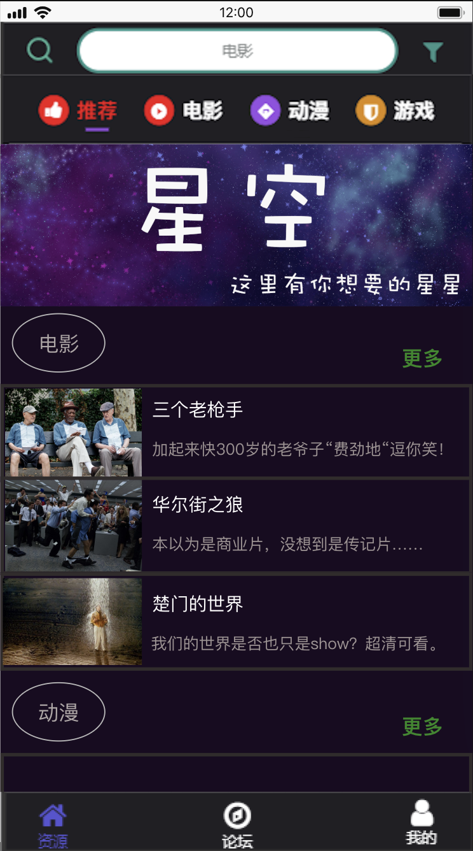 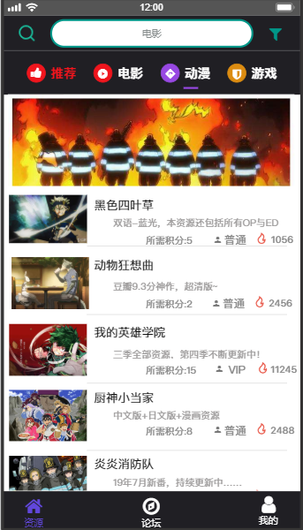 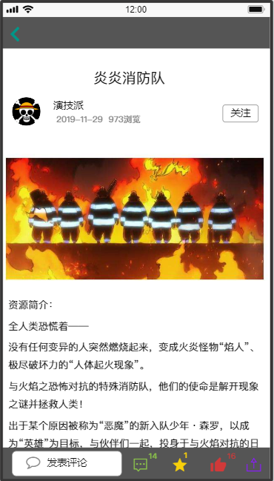

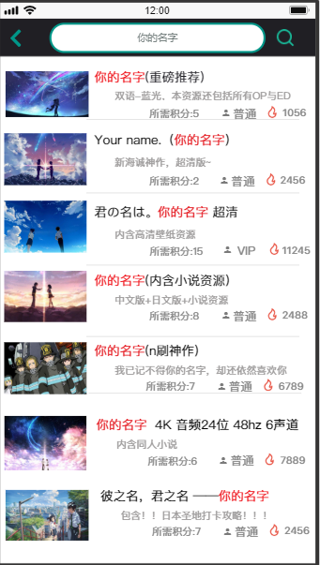 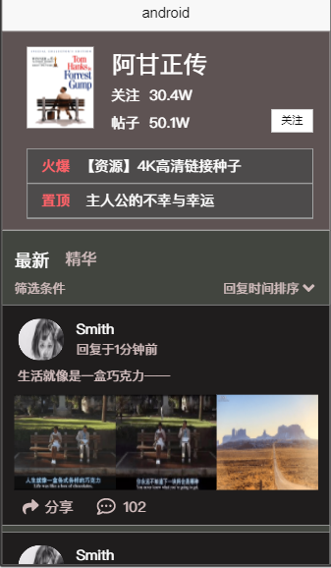 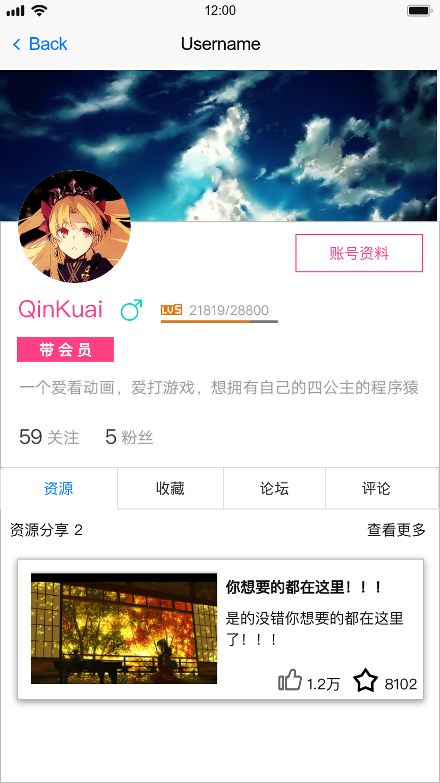

**3 Function Design**

The function of this platform is composed of three parts: resource sharing function, forum function and user information management function.

**3.1 Resource Sharing Function**

— Search for resources

* Upload resources: Users can upload their own resource links.
* ‘Like’ a resource
* User feedback: Users can provide feedback to the system administrator for a resource. For example, users can report a resource that has violated rules.

**3.2 Forum Function**

* Browse forum
* Post and Comment
* ‘Like’ a post or a comment

**3.3 User Information Management Function**

* Register and login
* User information
* User Rank: Users can upgrade with experience gained after completing corresponding tasks, and upgrade can unlock more advanced functions.
* Point system: Downloading cost points and Uploading bonus points.
* VIP user: VIP users have many privileges.